**ITEC 630**

*Information Systems Analysis, Modeling, and Design*

***Lecture Notes***

**An Example of DFDs for A Courses Registration System**

Created by Daniel LeRevised by Daniel Le 07/31/2016

**QUESTION**

A summary of business activities for registering courses for enrolled students and for registering class lists for faculty members at an online university is as follows:

*Students send in a course registration form consisting of their personal information and their desired courses. The system checks that the courses are available and that the student is academically qualified to take the course. Based on the checking results, the system will send to the student a confirmation and/or rejection letter with detailed information for each requesting course. Faculty members will receive registering class lists when the registration period is complete.*

1. Draw a context-level data flow diagram for the “Courses Registration” system.

2. Explode the above context-level diagram by drawing the logical data flow diagram level 0 showing all the major processes.

**SOLUTION**

1. Based on information described in the question, the following components are required for the context-level diagram.

Process name: Courses Registration System

External entities: Student and Faculty member

Data flows: Course Registration Form, Confirmation/Rejection Letter, & Class List

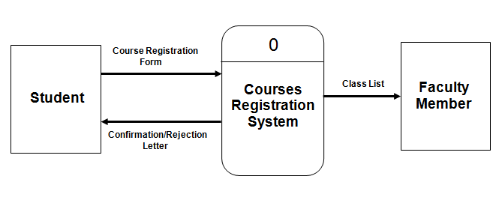

2. Based on information described in the question and the above context-level diagram, the following components are required for the diagram level 0.

Process names: Check Course Availability and Academic Qualification

Register Requesting Courses

Confirm/Reject Courses Registration

Generate Class List

Data stores: Courses (Course details)

Students (Student details)

External entities: Student and Faculty member

Data flows: Refer to the diagram

